**Greening the Erasmus+:**

**Tips for Eco-Friendly Travel to Slovenj Gradec, Slovenia**

As part of our commitment to sustainability, we encourage all participants to consider green travel options to Slovenj Gradec. Here are some tips to help you reduce your carbon footprint while making your journey as environmentally friendly as possible.

**1. Options for Public Transport**

Using public transportation is one of the most eco-friendly ways to travel. Slovenj Gradec is well-connected, and here are some green transport options:

* [**By Train**:](https://potniski.sz.si/en/timetable-results/)  
  Traveling by train is one of the most sustainable ways to reach Slovenj Gradec.
  + **From Ljubljana**: Take the train from Ljubljana to Dravograd, which is about 10 km from the town center. You can then take a local bus, a taxi, or even rent a bike to reach your accommodation.
  + **From Other European Cities**: Slovenj Gradec is connected to major European cities via rail networks, so check train services from your departure city.

 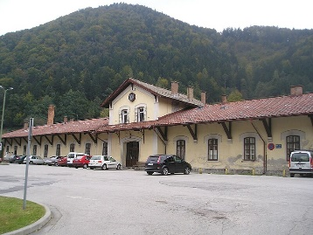

* [**By Bus**:](https://www.ap-ljubljana.si/en)
  + **From Ljubljana**: There are regular buses from Ljubljana to Slovenj Gradec, which is both affordable and low-emission. The journey takes about 1 hour 45 minutes.
  + **From Neighboring Countries**: If you're coming from Austria, Croatia, or Italy, there are international bus services that operate to Slovenia.

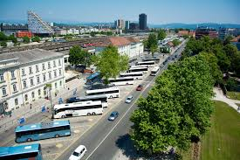 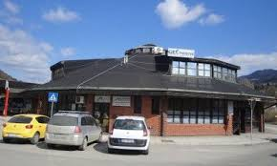

**2. Carpooling or Shared Rides**

If public transportation is not feasible from your location, consider carpooling or ride-sharing services.

* **Apps like BlaBlaCar** offer carpooling options across Europe, which can reduce emissions and save costs by sharing rides with others heading to the same destination.
* If driving is necessary, consider sharing the ride with other participants to minimize the environmental impact of multiple vehicles.

**3. Choose Eco-Friendly Flights**

For those flying in from abroad:

* **Book Direct Flights**: Choose direct flights whenever possible, as takeoffs and landings consume the most fuel.
* **Offset Your Carbon Emissions**: Many airlines offer carbon offset programs, where you can contribute to environmental projects to balance out your flight’s carbon footprint.
* **Fly Light**: Pack light, as lighter luggage means lower fuel consumption.

**4. Sustainable Transport Once in Slovenj Gradec**

Once you arrive in Slovenj Gradec, embrace green ways to get around:

* **Walk or Cycle**: Slovenj Gradec is a small, scenic town with walking and cycling paths. [Renting a bike](https://www.slovenija.eu.com/tour/rent-a-city-bike/) is a great way to explore the area while staying eco-friendly.
* **Electric Buses**: Slovenj Gradec offers electric shuttle services for tourists, which is another low-impact option for getting around the town and its surroundings.

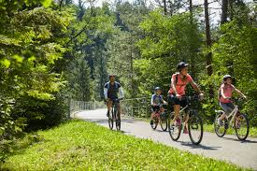

**5. Pack Reusable Essentials**

Be mindful of what you bring to reduce waste during your trip:

* **Reusable Water Bottle**: Slovenia has excellent tap water, so a reusable bottle will reduce plastic waste.
* **Eco-friendly Toiletries**: Opt for biodegradable soaps, shampoos, and reusable toiletry containers.
* **Reusable Shopping Bag**: Avoid single-use plastics by packing a reusable bag for your shopping.

By following these tips, you’ll help contribute to the environmental goals of “Greening the Projects” while enjoying the beauty of Slovenj Gradec in a sustainable way. Let’s make this a green journey from start to finish!